**School of Computer Science and Artificial Intelligence**

**Lab Assignment # 6.5**

**Program : B. Tech (CSE)**

**Specialization :**

**Course Title : AI Assisted coding**

**Course Code :**

**Semester : II**

**Academic Session : 2025-2026**

**Name of Student : A.Goutham**

**Enrollment No. : 2403A51L43**

**Batch No. : 52**

**Date :23-01-2026**

Task-1

### **Prompt**

Generate Python code to check voting eligibility based on age and citizenship.

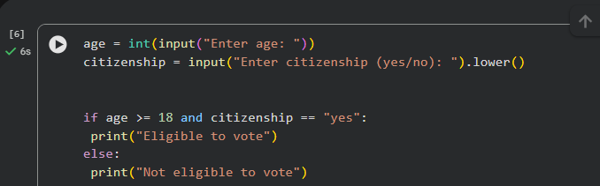

### **Explanation:**

age = int(input(...)) takes the user’s age as an integer.

citizenship = input(...).lower() reads citizenship status and converts it to lowercase for comparison.

if age >= 18 and citizenship == "yes": checks both conditions together.

print("Eligible to vote") executes when both conditions are true.

else: handles cases where one or both conditions fail.

Output:

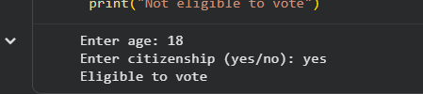

Task-2

Prompt:

Generate Python code to count vowels and consonants in a string using a loop.

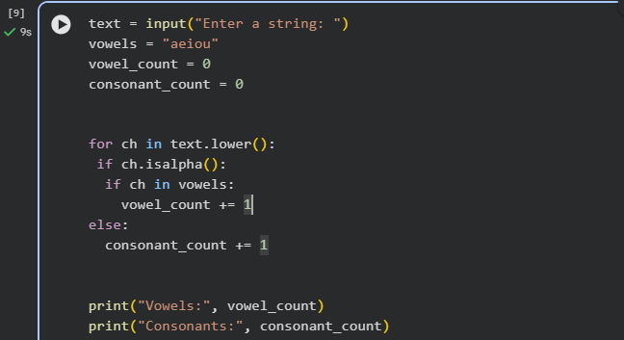

### **Explanation**

* text = input(...) reads the input string.
* vowels = "aeiou" stores all vowel characters.
* Counters are initialized to zero.
* for ch in text.lower(): iterates through each character.
* ch.isalpha() ensures only letters are counted.
* Inner condition checks vowel or consonant.
* Final print statements display the counts.

Output:



Task-3

Prompt:

Generate a Python program for a library management system using classes, loops, and conditional statements.

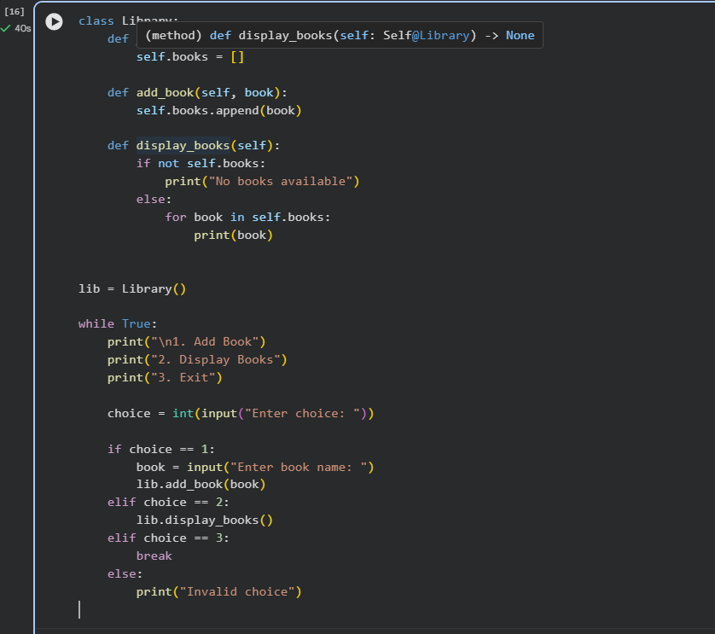

## **Explanation**

* Library class stores book details.
* List books is used to manage book records.
* add_book() adds a new book to the list.
* display_books() uses a loop to display all books.
* while True loop allows repeated user interaction.
* if-elif-else handles menu selection using conditionals.

Output:

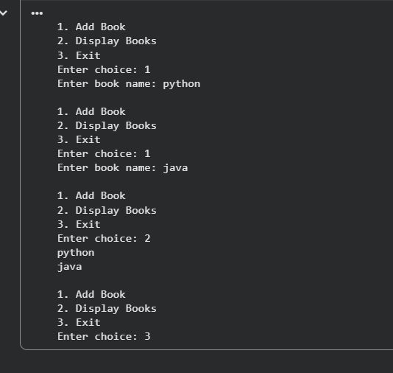

Task-4:

### **Prompt Used:**

Generate a Python class to mark and display student attendance using loops.

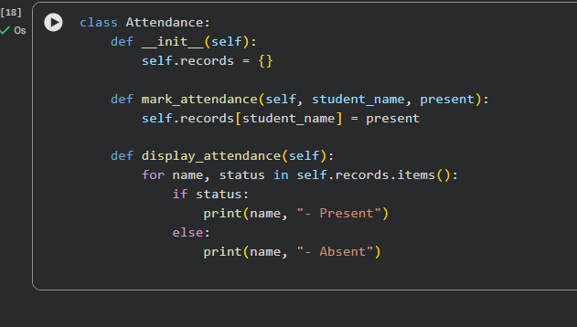

## **Explanation**

* Attendance class stores attendance details.
* Dictionary records stores student names and their attendance status.
* mark_attendance() records whether a student is present or absent.
* display_attendance() uses a loop to display attendance for all students.

Output:

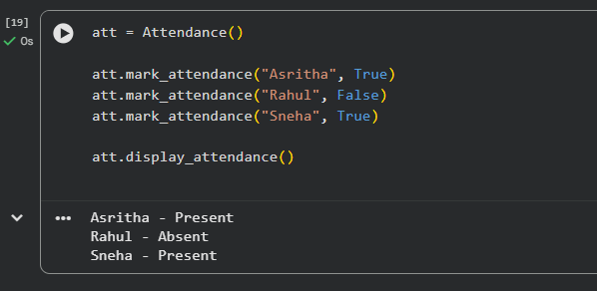

Task-5

Prompt:

.Generate a Python program using loops and conditionals to simulate an ATM menu.

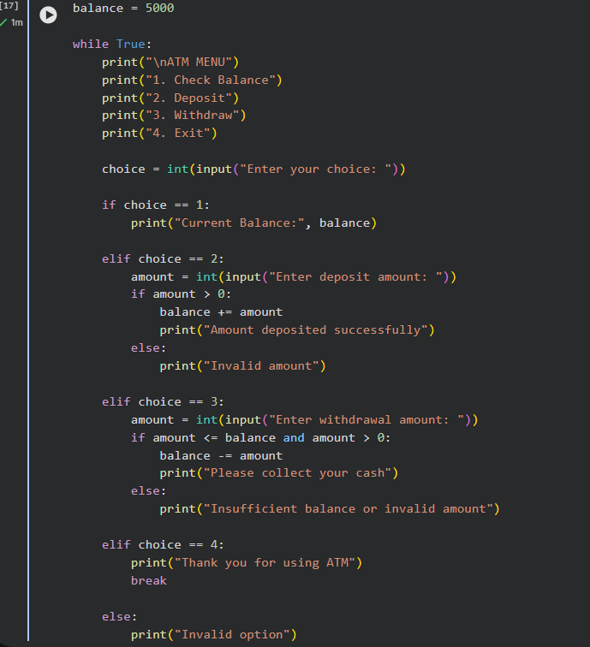

## **Explanation**

* while True creates a continuous menu loop.
* Menu options are displayed using print.
* if-elif-else handles user selections.
* Balance is updated using conditional checks.
* Loop exits when the user selects option 4.

Output:

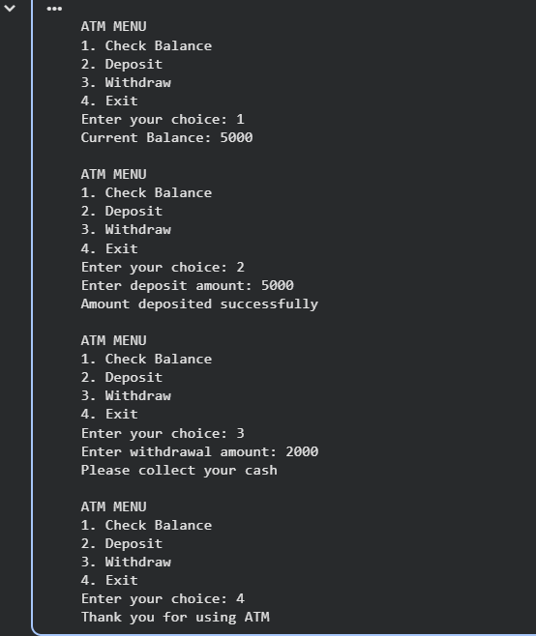

### **Conclusion**

In this experiment, AI-based code completion was used to generate Python programs for all five tasks involving **conditionals, loops, classes, and menu-driven logic**. Each task helped in understanding how AI can assist in writing correct and structured code. By reviewing outputs and making improvements, the importance of testing and ethical use of AI tools was learned.